Exploring the affect salinity has on the conductivity of water.

Rufus Gordon-Heywood 07/08/2023

Aim:

To determine if the salinity in water influences its conductivity.

Introduction:

Many countries around the world are facing water scarcity and people in poorer and less developed areas commonly end up drinking water that may not be safe for consumption (fix this to proper referencing). This risk can be minimised if people are able to check the quality of their water quickly and easily with a cheap tool such as a multimeter. 1 in 10 people do not have access to clean drinking water, and as a result over 3.5 million people die every year as a result of sickness or water related diseases (The World Counts, 2020). The salinity of water is a good baseline indicator of water quality, as can be seen from previous research done by the Environmental Protection Agency, as salinity can be a chemical stressor in the aquatic environment as changing salinity levels can affect aquatic biological organisms. Currently there are few experiments that have been conducted that see if increased water salinity leads to increased conductivity. One exception of this is past research (Anna F Rusydi, 2018) showing conductivity and water salinity to be closely corelated, but this report is outdated and the experiment should be repeated to ensure the results are true. This is a research gap, as if there was a link, people who are unsure of the quality of the water they are drinking would be able to measure the water’s conductivity using a multimeter and thus easily measure the baseline water quality. Distilled water is water that has had its impurities removed through evaporating the water and then recondensing it (Blades, 2020). As there are no metal impurities, it has no ions. Water itself is not conductive, it is the metal impurities within the water are very conductive, as they are ionic, causing them to be a great conductor of electricity. Ionic compounds cannot conduct electricity when in solid form, as they are held together and unable to move freely. However, when they are dissolved in a liquid such as water, they are able to move freely and carry electric current. Table salt is made up of sodium and chloride. Sodium has a positive charge and chloride has a negative charge, so they bond together into a tight lattice. When the sodium chloride goes into the water it dissociates into ions (USGS, 2021), allowing it to carry the electrical current from one electrode to the other. The more ions in the water, the more electrical current they can carry. To measure this, I will run a current from a 9V battery through water with varying levels of salt and record the current using a multimeter (David Whyte, 2008).

Hypothesis:

If the salinity of water increases, then the conductivity of the water will increase.

Equipment:

* Alligator clips
* A digital multimeter
* Uninsulated copper wire
* A 9V battery
* An ice cube tray
* A small ball of blue tack (2cm diameter)
* Salt
* Distilled Water
* 100ml beaker

Method:

An ice cube tray was taken, and each section was filled with equal amounts of prepared water. In the first test, 1g of salt was added to 100ml of water, stirred 10 times so that it dissolved, and then poured equally into each section of the ice cube tray. The conductivity of each section was measured with a digital multimeter, and the results were recorded in a table. The multimeter was wired to a 9V battery and had copper wires as electrodes. A piece of blue tack was used to ensure the copper wires remained an equal distance from one another throughout. The multimeter was set to measuring milliamps, as this showed how much current flowed through the water. The ice cube tray was then thoroughly washed to make sure it was free of salt. This method was repeated 3 more times with varying amounts of salt. Test 2 used 2g, test 3 used 4g, and test 4 used no salt as a control. The conductivity of the air was also tested to ensure the multimeter was correctly calibrated.

Fig. 1

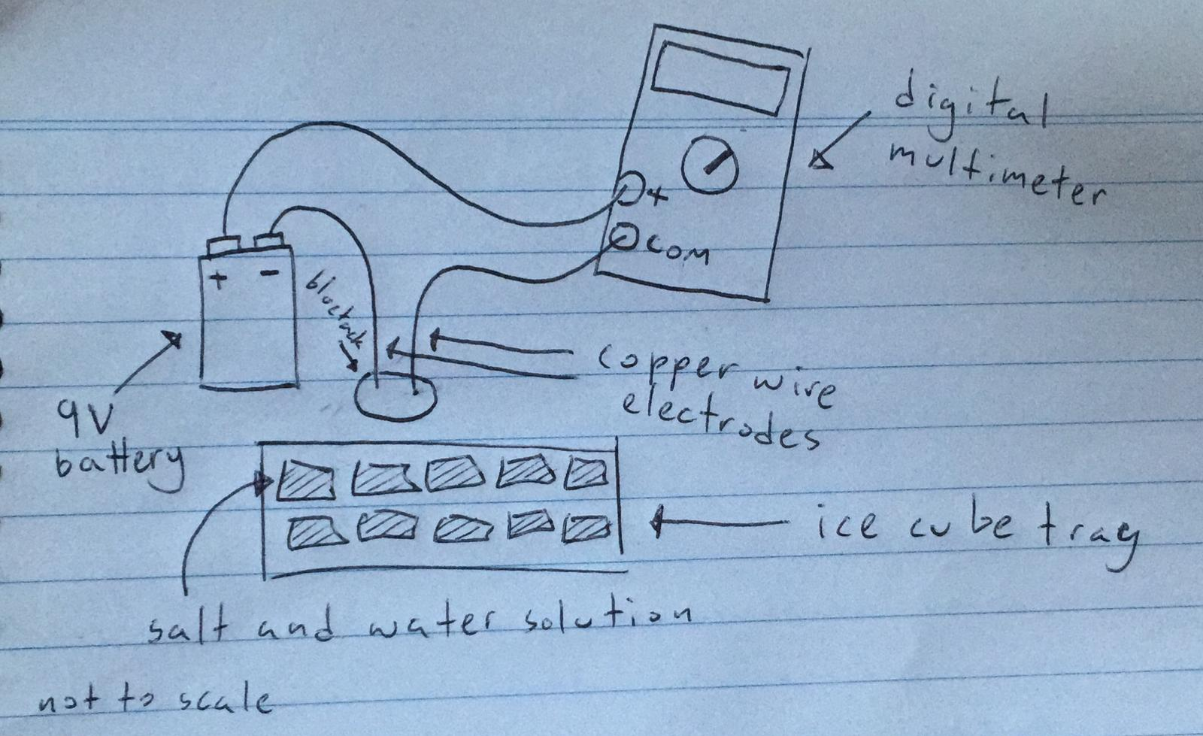

Variables:

Fig. 2

|  |  |
| --- | --- |
| Independent (change) | Salinity of the water. |
| Dependent (measure) | Conductivity of the water. |
| Controlled (same) | Water amount, conductivity tester, environment, container for the water, battery used, blue tack used, spacing of the electrodes from each other, length of copper wire used, temperature of the water, type of salt used, how well the salt had dissolved. |
| Control Trial | Test the conductivity of water with no salt. |

Results:

Fig. 3

|  |  |  |  |  |  |
| --- | --- | --- | --- | --- | --- |
|  | With air | With just water | 1g salt | 2g salt | 4g salt |
| Average | 0.01 | 0.93125 | 11.74375 | 15.8375 | 26.825 |
| Standard Deviation | 0 | 0.095 | 1.293 | 1.002 | 1.660 |
| Number of Samples | 1 | 16 | 16 | 16 | 16 |
| Standard Error | 0 | 0.024 | 0.323 | 0.250 | 0.415 |

Fig. 4

Fig. 5

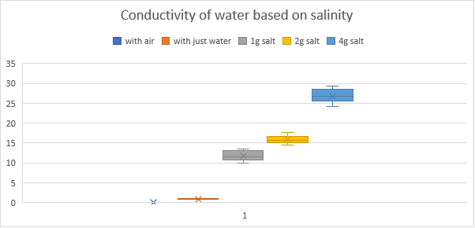

Fig. 6

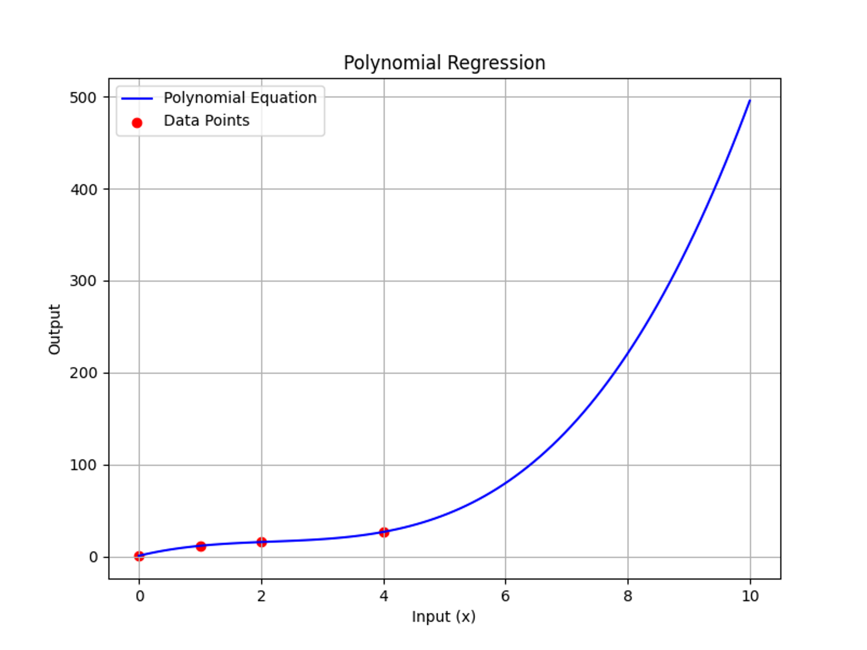

The findings were that pure water had an average of 0.93mA current flow, 1g of salt in the water had 11.74mA of current flow, 2g of salt had 15.84mA of current flow, and 4g of salt had 26.83mA of current flow. Pure water had a standard deviation of 0.095, 1g of salt had 1.293 standard deviation, 2g of salt had 1.002 standard deviation, and 4g of salt had 1.660 standard deviation.

Discussion:

The data shows that an increase in salinity leads to an increase in conductivity, which agrees with the hypothesis as well as past research (Anna F Rusydi, 2018). The standard error of the 4g of salt (0.415) was higher than that of the 1g and 2g (0.323 and 0.250 respectively), which gives us more reliability in the 1g and 2g measurements. This may show that as there is an increased amount of salinity, the conductivity of the water is more highly affected, as small variations in saline content led to more spread-out data. Interestingly, the relationship between conductivity and saline content is not linear. Through the use of polynomial regression, it is evident that there is an exponential relationship between saline content and conductivity, as a small increase in salt leads to a larger increase in conductivity each time.

Many variables could’ve affected the validity of the experiment. One of these could have been not properly mixing in the salt. This would’ve caused a decreased conductivity of the water, as not all of the salt would have been dissociated into ions, meaning there would be less ions to carry the electric current.

Another variable that could’ve affected the validity of my experiment was trace amounts of salt left over between trials. This would’ve caused the readings to show that the water was more conductive than it really was.

A problem with my experiment is that I short circuited a multimeter by accidentally allowing two exposed wires to touch. This meant I had to use a different multimeter which was cheaper and less accurate. To prevent this from happening again, I should use insulated wires so that it is protected from short circuiting.

A further issue with my experiment was that the electrodes were held together with a blob of blue tack, which is a soft material. This allowed the electrode distance to vary throughout measurements, and the further the electricity must travel, the more charge that would be lost, meaning it would show up as less conductive.

An improvement to my method would be to use a conductivity probe rather than a multimeter, as it is able to provide more accurate readings as the probes are kept at a set distance from each other. It also has a more accurate sensor which would give more precise results.

My experiment could be expanded on by testing a variety of suspensions with different amounts of dirt in the water to see if the dirtiness of water affects its conductivity, which would be an even greater help in determining baseline water quality with a simple tool.

Conclusion:

The conductivity of water with varying amounts of salt was determined using a multimeter. The mean conductivity of 1,2, and 4g of salt’s conductivity exponentially increased, from 0.9 mA to 26.825 mA, which shows that the more salt you add, the more conductive it becomes. The results were dependant on how well the salt was dissolved into the water, so stirring the salt until it has completely dissolved would allow for more accurate results. These findings show that a multimeter can be used for a quick, cheap, and easy baseline measurement of water quality. This is crucial in places where they don’t have access to a safe and reliable water source as it would allow them to check the quality of the water before they drink it.

References:

Rusydi, A.F. (2018). Correlation between conductivity and total dissolved solid in various type of water: A review. *IOP Conference Series: Earth and Environmental Science, 118,* 0122019.

The World Counts. (2020). The World Counts. theworldcounts.com. <https://www.theworldcounts.com/challenges/planet-earth/freshwater/deaths-from-dirty-water>

United States Geological Survey. (2021). Water molecules and their interaction with salt. usgs.gov. <https://www.usgs.gov/media/images/water-molecules-and-their-interaction-salt>

Blades, N. (2020, July 1). What Is Distilled Water? WebMD. <https://www.webmd.com/diet/distilled-water-overview>

David Whyte. (2008, November 13). Electrolyte Challenge: Orange Juice Vs. Sports Drink (B. Finio, Ed.). Science Buddies; Science Buddies. <https://www.sciencebuddies.org/science-fair-projects/project-ideas/Chem_p053/chemistry/electrolyte-challenge-orange-juice-vs-sports-drink>

Appendix:

Fig. 1 – A labelled diagram showing the setup of the experiment.

Fig. 2 – Independent, dependant, and controlled variables in the experiment.

Fig. 3 – Raw data collected during the experiment.

|  |  |  |  |  |  |
| --- | --- | --- | --- | --- | --- |
| Trial Number | With air | With just water | 1g salt | 2g salt | 4g salt |
| 1 | 0.01 | 0.9 | 12.7 | 15.4 | 26.9 |
| 2 | 0.01 | 1.1 | 12.1 | 15.1 | 26.6 |
| 3 | 0.01 | 1 | 13.3 | 16.7 | 29.2 |
| 4 | 0.01 | 0.9 | 9.9 | 14.6 | 26.5 |
| 5 | 0.01 | 0.9 | 10.8 | 17.4 | 24.6 |
| 6 | 0.01 | 0.9 | 13.4 | 15.2 | 28.9 |
| 7 | 0.01 | 0.8 | 13.6 | 14.8 | 26.7 |
| 8 | 0.01 | 0.8 | 13 | 16.4 | 29 |
| 9 | 0.01 | 1 | 13.1 | 16.2 | 25.5 |
| 10 | 0.01 | 1 | 10.7 | 17.6 | 26.8 |
| 11 | 0.01 | 0.9 | 10.1 | 15.8 | 24.7 |
| 12 | 0.01 | 0.9 | 11.4 | 14.5 | 24.2 |
| 13 | 0.01 | 0.9 | 11.3 | 16.7 | 27 |
| 14 | 0.01 | 0.8 | 10.8 | 15 | 27.5 |
| 15 | 0.01 | 1 | 11.6 | 16.8 | 29.4 |
| 16 | 0.01 | 1.1 | 10.1 | 15.2 | 25.7 |
| Average | 0.01 | 0.93125 | 11.74375 | 15.8375 | 26.825 |
| Standard Deviation | 0 | 0.0946485 | 1.293042 | 1.001915 | 1.660321 |
| Number of Samples | 1 | 16 | 16 | 16 | 16 |
| Standard Error | 0 | 0.0236621 | 0.323261 | 0.250479 | 0.41508 |

Fig. 4 – A dot plot of the average results with a line of best fit.

Fig. 5 – A box and whisker plot showing the standard error, mean, and interquartile range of my data.

Fig. 6 – A graph showing polynomial regression performed on the data to predict future trends.

add more detail to discussion and reference properly